Zaffar Sikkander to Play College Golf at La Salle University
April 10, 2017/by Stacy Shanks
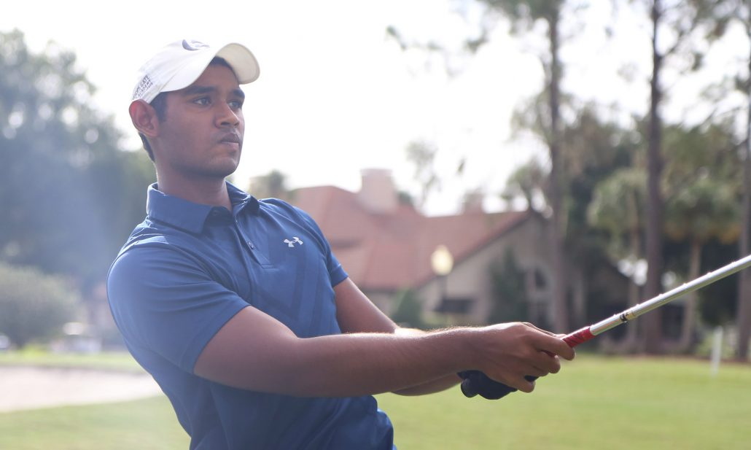

Zaffar Sikkander, a Bishops Gate Golf Academy Post Graduate student, has his sights set on being a professional and one day winning the British Open at St. Andrews.
To achieve that goal, Sikkander turned to BGGA three years ago as an undergraduate to fine tune his game and receive assistance with college recruiting. His Post Grad year allowed him to live independently and better prepare for the rigors of college life and golf.
“College recruiting takes a long time,” said Sikkander. “The earlier you start the better. The more schools you write to, the better the outcome. Even if you have a set dream school, you should have a lot more schools you would want to reach out to just to keep your options open.”
Sikkander’s gap year paid off as he’ll be playing golf for La Salle University in the fall.
“They have a really good team,” said Sikkander. “The coach believes in the same way of practice that I do. He likes making the guys compete and perform even in practice. If you play well consistently, you have a chance to be exempt for the whole season, but he makes everyone fight for a spot.”
One of Sikkander’s biggest challenges at BGGA was learning how to balance being a student-athlete, and his experience the past three years especially during his Post Grad year has helped prepare him for this next chapter in his life. There are often academic reasons why taking an extra year between high school and college is the best course of action.
Having been at the Academy for so many years, Sikkander will miss a few things especially the friendships he’s made, learning about different cultures and of course the magnificent BGGA golf facilities.
“BGGA is one of the best practice facilities in the world,” said Sikkander. “You have world-class short game areas. The putting greens are always good and the chipping greens always react well. The course is good because it challenges you too. You can definitely get better. You can hit any shot here that you want too.”
With all the experience he’s gained, you might see Sikkander’s name and the Sri Lanka flag atop the British Open leaderboard in the not too distant future.

