Mateo Lancheros Finds Early Success in Golf Career, Commits to Ottawa University
April 12, 2017/by Stacy Shanks
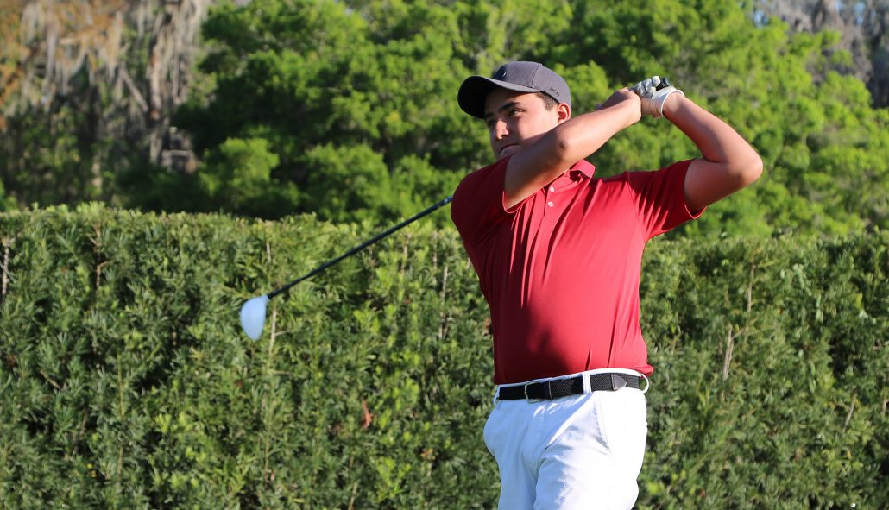

Mateo Lancheros only started playing golf a year and a half ago when he decided professional cart racing in Colombia was getting to expensive. Fast forward to today and Lancheros is going to play collegiate golf for Ottawa University in Sunrise, Ariz.
Lancheros started at Bishops Gate Golf Academy as a Post Graduate student in August 2016 to learn more about the game and college placement. After only eight months, his game and his college planning and preparation have paid off.
“I came to BGGA to really learn about golf,” said Lancheros. “In Colombia you can play tournaments but they aren’t big. Here you have the ability to train like a professional and train with really good junior players. There’s another level of golf here. It was an experience I could not have found at any other academy.”
Why does Lancheros love golf? He loves it because of the mental side of the sport.
“I love to have control of my mind in this sport,” said Lancheros. “You might not have the best swing or the best score, but if you have control over your mental game, you can do whatever you want.”
Lancheros is excited to play in collegiate tournaments and be a part of the first men’s golf team at Ottawa University, as the college opens its door this fall.
“It’s a good opportunity because it’s a brand new university,” said Lancheros. “I’m going to be one of the first people on the team. There are new students and buildings, and it’ll be a really good experience.”
While Lancheros is excited for the new opportunities to come, he’s going to miss his coaches at BGGA who have felt like fathers to him.
“I’m going to miss my friends and my coaches,” said Lancheros. “Jonathan Yarwood and Nate Dougherty have really helped me, especially with my mental game. Nate and Jonathan are like my fathers here.”
While Lancheros has found quick success in golf, his dreams of playing college golf have come true. Maybe his dream of winning the Masters one day will also come true.

