Jakob Raichle Commits to Play Golf at Springfield College
April 10, 2017/by Stacy Shanks
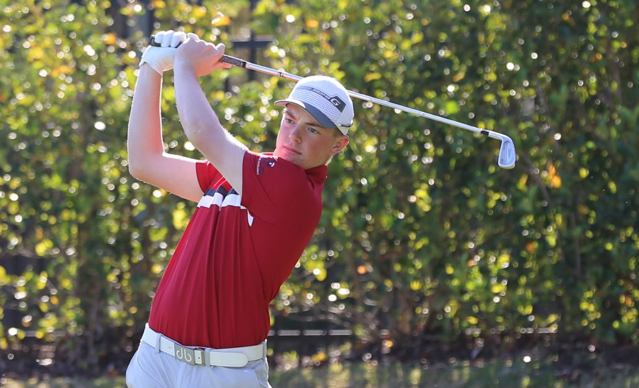

Playing golf at the age of five with his dad is what got Jakob Raichle hooked on golf.
“Golf’s really challenging,” said Raichle. “You can never really perfect it. You’re always changing something or working on something which I really like.”
Raichle, a senior and student at Bishops Gate Golf Academy, learned what it’s like to be a student-athlete these past two years before even committing to play golf for Springfield College in the fall.
“Staying positive with golf and in school has been a challenge,” said Raichle. “It’s not just about being away from home but it’s also being a student-athlete. There’s a lot of stress involved and my support system, my mom, dad and my coaches, never gave up on me so I didn’t give up on myself.”
Racihle not only learned how to be a student-athlete, he improved his game along the way and picked up knowledge about the college recruiting process through BGGA’s College Planning & Placement.
“My ball striking is definitely a lot better, but my mental game has really grown with the help of the staff here,” said Raichle. “I just thought college was something that you did your senior year. When I came here in my junior year, I was kind of already behind the eight ball. Bishops Gate really helped me get on track. Now I’m committed and it feels pretty good!”
While Raichle enjoyed the warm weather, he is ready to be back in the cold and attend a college that’s close to home. He’s going to have a harder time leaving behind the golf facilities.
“The facilities here are absolutely incredible,” said Raichle. “I’ve never played golf in a place like this. Having access to it whenever we want is awesome. When I first came here I couldn’t believe it. That’s going to be a hard one to leave behind.”
With his support system at BGGA, Raichle will graduate this spring and take the next step in his golf career.

