David Fu’s Passion for Golf Drives Him to Commit to Play at Earlham College
April 10, 2017/by Stacy Shanks
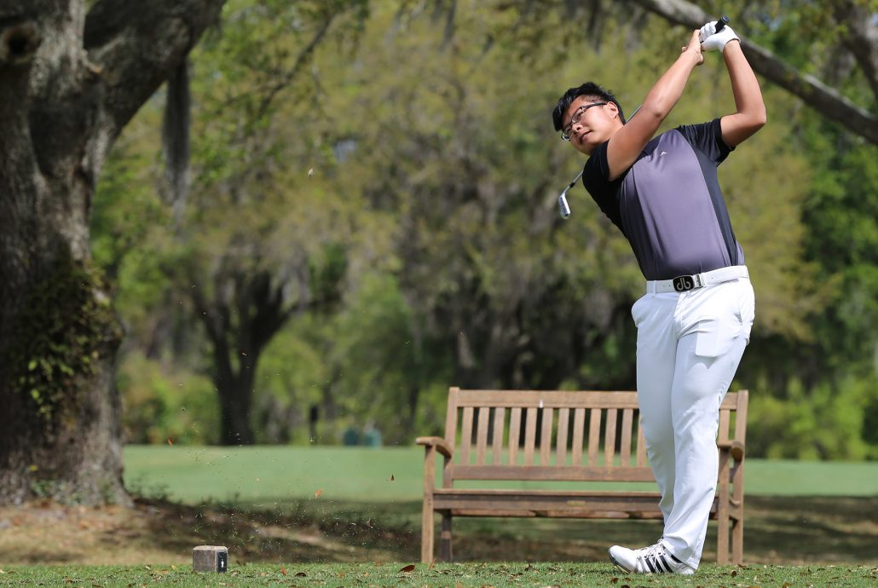

David Fu started playing golf in China when he took a golf class at school when he was 11 years old. Now seven years later, Fu is living in the U.S., honing his game as a senior at Bishops Gate Golf Academy and on his way to play golf at Earlham College this fall.
During his time at BGGA, Fu has seen changes in his game.
“My ball flight is more consistent and better than before,” said Fu.
Fu is passionate about playing golf because every shot is different and it’s a challenging sport. It’s also been a challenge to be a student-athlete.
“It’s practice every day,” said Fu. “In the morning it’s school and then practice. I think the schedule will be pretty similar to college.”
Fu has enjoyed everything about his experience and credits playing in tournaments with his friends as his best memories.

