Chun Yan Leong Ready for Transition from BGGA to Play Golf at University of Wisconsin-Parkside
April 10, 2017/by Stacy Shanks
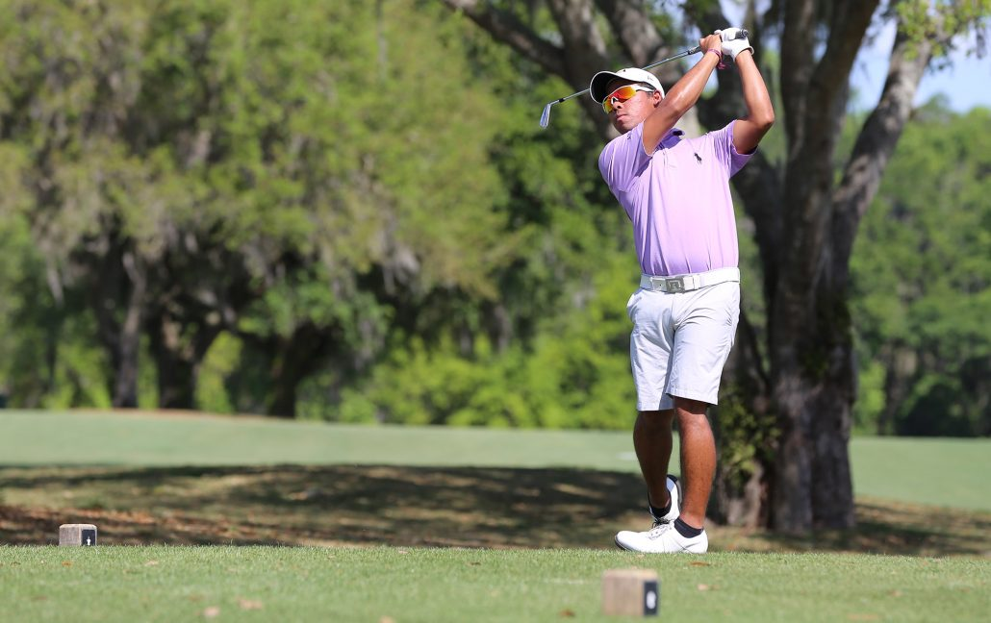

Growing up in Malaysia, Chun Yan Leong had passions for snowboarding, competitive swimming, sailing, scuba diving, skiing, track and field as well as golf. As you can see, Leong has a love for competition and sports but golf is the game that stuck. Golf is the one helping him realize his dreams of playing collegiate golf as a platform to play professionally.
“I just love to compete and meet new people,” said Leong. “I think golf is a great way to really challenge yourself, because golf is not only about being physically fit, it’s also about being mentally fit.”
Leong, a senior Bishops Gate Golf Academy student, will start that dream in the fall with University of Wisconsin-Parkside.
“I think the University of Wisconsin-Parkside is a good fit for me because the overall environment there is very nice,” said Leong. “I’ve seen their results and they’ve done some pretty good work as a team. They are a bunch of nice guys and they like to interact with each other. I get along with the coach too! I think I’ll fit in very well.”
Before coming to BGGA, Leong only had “partial knowledge” about getting recruited. While gaining more knowledge about the College Planning & Placement process, Leong also saw improvements in his game.
“My mental game has really changed a lot even though there’s still areas to improve upon,” said Leong. “I can still improve on every area of my game because being good is not enough. There’s always another guy who is going to be working harder and smarter than you. He’s going to want to take your trophy, your scholarship and he’s the one who wants to be you so even though I’ve reached a really good level, I still want to keep on working as hard as I can.”
Leong isn’t a stranger to hard work. He was able to overcome the challenges of being a student-athlete and feels comfortable with his transition to college.
“I’ve managed to find a great way to keep up with my school work and continue to compete in as many tournaments as I can. I needed to be able to learn how to do that before college,” said Leong. “I’m going to be competing even more and occasionally missing classes. That’s a skill I’ve really built up here at Bishops Gate. I’m feeling comfortable and prepared for college.”
Leong is grateful for the memories he’s made at BGGA, the coaches, the facilities and the warm weather.
“I’m going to miss my friends and these unbelievable training facilities that really helped me to get my game to where it is now,” said Leong. “I’m so grateful to have worked with some of the best coaches in the world. I really don’t have any other words to describe how grateful I am to have experienced this.”
Leong’s dream of using college as a platform to hone his game and turn professional is on it’s way to becoming true. One dream that’s still on the horizon is to win the Masters, and with his mentality, you just might see Leong wearing that famous green jacket.

