Billy Rosemeyer Improves Game at BGGA and Commits to Play Golf at Capital University
April 10, 2017/by Stacy Shanks
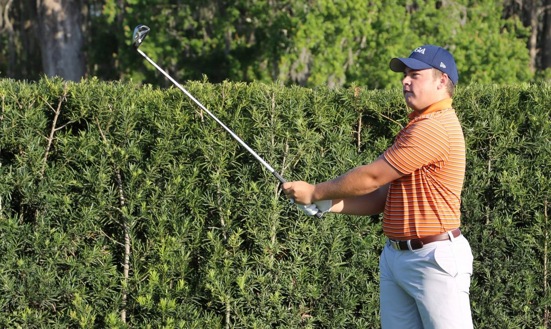

Billy Rosemeyer, a Bishops Gate Golf Academy Post Graduate student, knew at 13 years of age when he started playing golf competitively that he wanted to play golf in college.
That dream will come true this fall when Rosemeyer joins the Capital University men’s golf team.
“My goals are to be a better player and really help the team out,” said Rosemeyer. “I’m not looking to play professionally. I just want to be a very good amateur player. My dad played college golf and he said those are going to be some of your best friends forever and you’ll make good relationships for the future whether it’s in business or just having fun on the golf course.”
To make that dream a reality, Rosemeyer turned to BGGA for his Post Grad year to get his game and college recruiting on the right track as he felt he started the college planning process too late.
“I’m a better ball striker and my mental game has improved a lot,” said Rosemeyer. “I was struggling with trying to hit a perfect shot or perfect score which is not realistic. I came to that realization, and it’s helping my game.”
Rosemeyer said the BGGA facilities aided his game because of the variety and challenges the short game areas provide. He’ll enter college with his short game being one of his greatest strengths.
“Having the 11 hole golf course with different tee boxes and different looks off the tee,” said Rosemeyer. “I’ve taken advantage of that being able to go out and hit multiple drives off each tee. It’s helped me compared to a regular Academy golf course.”
Rosemeyer loves the game and feels his father and golf coach back home, Joe Borris, have influenced his game the most.
“I just love the game,” said Rosemeyer. “I really think it’s interesting. Some sports you don’t have to think too much. You just play your position. As an individual game, you really have to think about all the aspects of the game. I thought it was pretty interesting and that’s why I fell in love with it.”
With a passion to be a great amateur player, Rosemeyer will leave BGGA with the right skill set to be a student-athlete in college.

