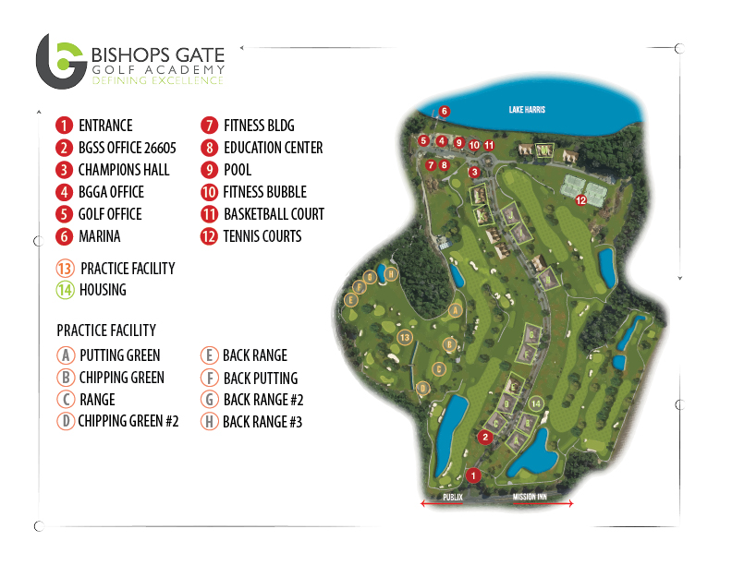
LOCATION, TRANSPORTATIONS & DIRECTONS

LOCATION: BGGA is located on Howey-in-the-Hills right next to Lake Harris in Florida’s Lake County, just 45 minutes from Orlando Airport.

AIRPORT TRANSPORTATION: Transportation from and to the airport are offered by BGGA with a partnership the Academy has with Mears Transportation. In case arrival and transportation is required, families, students and agents must send a Transportation Request at least a week prior to your visit in order for BGGA to prepare.

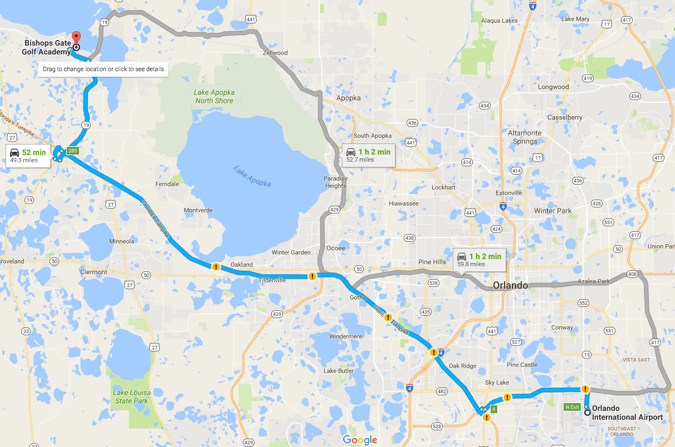
DIRECTIONS: Follow the directions based on the map placed below.

- Exit MCO Orlando International Airport and take FL-528 W highway
- Take exit 4 towards Florida’s Turnpike
- Drive from Florida’s Turnpike to Lake County and take exit 285 from Florida’s Turnpike.
- After the toll, take a left at the light.
- Turn left towards Highway Road Fl-19 and drive to Bella Vista Dr.
- Turn right on Bella Vista Dr. to enter Bishops Gate Golf Academy

