“Upping the Ante” - BGGA’s 2nd Annual Fitness Challenge

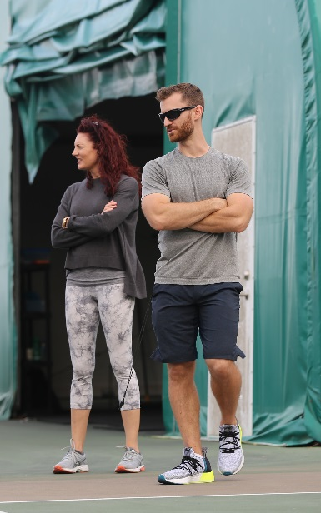
This last semester saw BGGA students competing in the 2nd Annual Fitness Challenge, an initiative developed by Performance Coaches Karen Harrison and Justin Smith. The goal - to bring out the competiveness in BGGA student athletes and reward effort, attitude, discipline, team work as well as individual performances in the physical training setting. The event which began in early January, extended over 10 weeks, all the way through to Spring Break (although make-up testing will continue to take place up until the end of this month).

Each week various challenges were set and points awarded for top performances and/or improvement either on an individual or team basis. Endurance or power based activities were common, but also included were a few out-of-the-box ideas designed to test a student’s discipline, memory or ability to make decisions in the heat of the moment that could alter an outcome. Consider for example a simple game of Tic-Tac-Toe conducted as a relay running team event! Or the “Quiet Game” – a session in which students were not allowed to speak to one another – the session was designed to promote a concept called “deliberate practice”, oft cited as a necessary component in developing excellence and mastery.
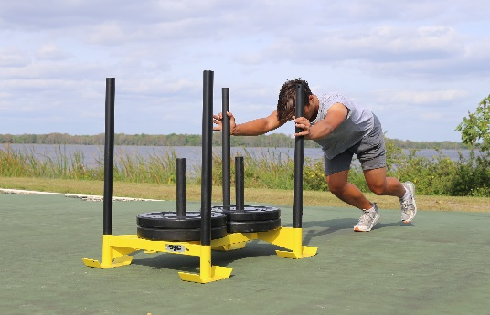
Other challenges included holding a front plank for as long as possible (with good form of course) – our record this year – Tyden Wilson with 8 mins 33 secs. Try to match that effort! The male and female winners of our “Mile Run” this year were Michael Boer (5mins29s) and Savannah Weyrauch (7mins22s) respectively, with points also awarded to top 10 finishers and individuals recording improved times. Other challenges included an obstacle course, quizzes based on educational sessions, a Dodge Ball match, timed circuits, medicine balls throws, vertical jump height (power testing) and even a Multi-Stage Fitness Test (aka The Beep Test).
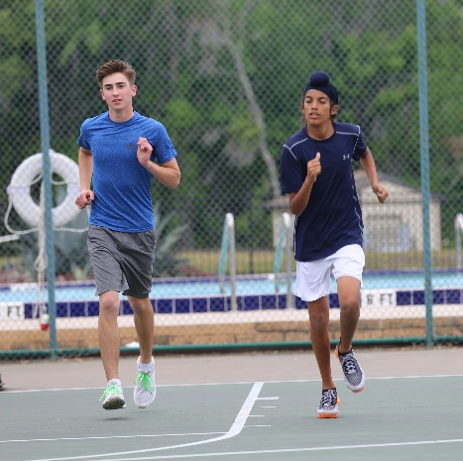
By the end of the designated time period, the top 10 students on the leaderboard will be rewarded with an adventure based activity off-campus. This year we are looking at Orlando Tree Trek Adventure Course, a zip line and ropes course, as the destination for our student group. It should be a fantastic afternoon celebrating the efforts of our young developing golf athletes.

The key this year to landing atop of the leaderboard is no surprise - CONSISTENCY. Regular attendance, ensuring that good hydration is maintained throughout the day, fueling appropriately for training sessions, developing good sleeping habits and essentially putting forth a maximal effort every session is what it takes to be performing optimally each week.

While the points are still being finalized here are some of the students who made it onto the leaderboard this year with exceptional performances – Savannah Weyrauch, Daniel Song, Tim Winter, Yoko Tai, Georgy Voronov and Egor Zotov. Congratulations to all who participated and to those who found a way to get it done.

Fitness Challenges:

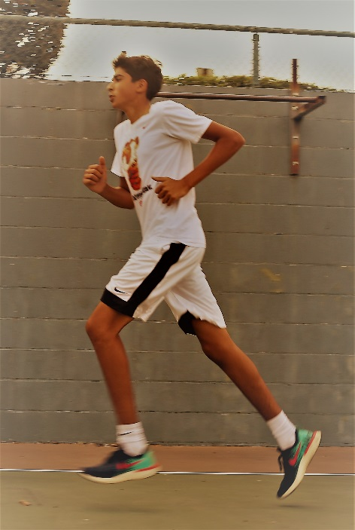
Week 1: Physical Competence Testing Results (based on our Fitness Reports) for Best Male and Female and Most Improved +
The Mile Run.
Week 2: The “Quiet” game - Encouraging reflection while in fitness class and to quiet the chatter so that the students can focus on their task at hand.
Circuit – How many rounds can you complete in 15mins?
Week 3&4: Quizzes – (1) What is the In-Place Warm-up; (2) Sleep
The Burpee Challenge
Week 5: Vertical Jump Height + Rotational Medicine Ball Throws
Week 6: Holding a front plank for the longest possible time.
Team Challenge-Dodge Ball Game
Week 7: Repeat Mile Run + Improvement Points +
Essay on “what I have learned in fitness”
Week 8: Team Challenge -Tic Tac Toe
Week 9: Obstacle Course – Individual + Team Points
Week 10: The Beep Test + Improvement Points

Diagram 1 – Performance Coaches Karen and Justin
Diagram 2 – Georgy pushing a loaded sled during the circuit
Diagram 3 – The Beep Test – Tyden and Zoravar
Diagram 4 – The Beep Test - Sumaer

